ER Mesh Generation Tank Tutorial

Conceptual Diagram
In this example, we build a mesh of a laboratory tank as shown in Figure 1. This example can be found in the jupyter notebook ERTtank1.ipynb. The notebook clear_files.ipynb clears all files generated before running ERTtank1.pynb.
In the run mode ERT1 example (mode_ERT1) the defined surface boundaries (flag=2) were far enough away from the electrode locations such that these boundaries did not influence the data; surface boundaries were defined in mode ERT1 as having zero potential. In contrast, in a laboratory tank, the tank boundaries are close enough to the electrodes to influence the data. Therefore in run mode ERTtank1, surface boundaries (i.e. tank boundaries) (flag=2) are computationally equivalent to defining a zero flux boundary.
The other difference in a laboratory tank is a ghost node must be defined to use the mesh in the forward and inverse modeling run modes. E4D simulates potentials by solving for the pole solution at each electrode and subtracting the potential generated by the current sink electrode. For example, the total potential P_{t} between electrode A and B is solved as:
P_{t}=P_{A}-P_{B}
However, the tank boundaries prevent computing the solution of P_{A} and P_{B} directly, so a ghost node is used which serves as the current sink electrode for every pole solution. Since the same ghost sink is used for every electrode pole solution, the effects of the sink cancel out when the potential from the current sink is subtracted from the potential from the current source. In modes ERTtank1 and SIPtank1, the total potential P_{t} between electrode A and B, where the ghost sink is P_{g} is computed as:
P_{t}=(P_{A}-P_{g})-(P_{B}-P_{g})
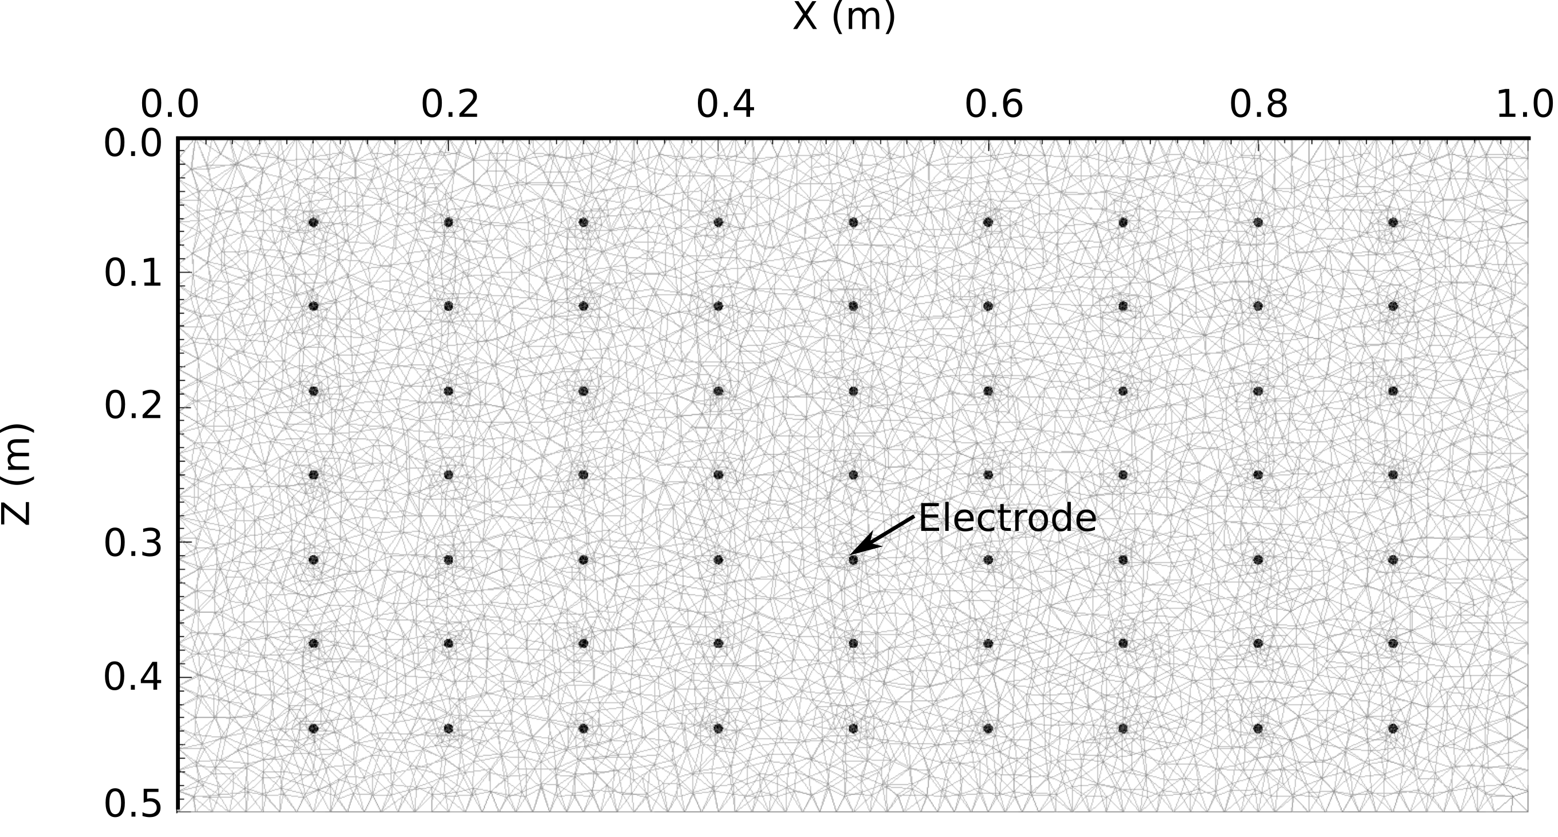
Figure 1: The schematic of the laboratory tank mesh used in this example.

Building the Mesh
In addition to the mesh configuration file, the run configuration file e4d.inp is needed to build the mesh. In mode ERTtank1, the only file that must be listed is the mesh configuration file. The run configuration file for this example is shown below.
<begin run configuration file e4d.inp> (this line is not included in the file)
ERTtank1
tank.cfg
<end run configuration file e4d.inp> (this line is not included in the file)
To build the mesh, execute the command:
<e4d_dir>/bin/mpirun -np 1 <e4d_dir>/bin/e4d
or
mpirun -np 1 e4d
if <e4d_dir>/bin is in the executable path, where <e4d_dir> is the E4D installation directory. E4D builds the input files for triangle and tetgen, and calls each to build the mesh. E4D then builds a conductivity file for the mesh as specified in the mesh configuration file, and calls px to build a file for visualization. The files generated include:
File | Generated by | Description
tank.poly | e4d | Tetgen input file generated by E4D. Not used in run modes > 1.
tank.1.node | tetgen | Tetgen node file. Gives the nodal coords of the mesh.
tank.1.ele | tetgen | Tetgen element file. Describes how nodes are connected to form elements.
tank.1.face | tetgen | Tetgen face file. Describes which nodes form boundary faces.
tank.1.neigh | tetgen | Tetgen neighbor file. Provides neighbors of all elements.
tank.sig | e4d | Conductivity file. Describes element conductivities and is written to the visualization file.
tank.xmf  tank.h5 | px | Xdmf files used to visualize mesh and conductivity distribution.
tank.exo | bx | Exodus file used to visualize mesh and conductivity distribution.

<begin file tank.cfg> this line is not included in tank.cfg

1.3 1e12 mesh quality (m_qual) max volume (max_evol_def)
0.0 bottom of mesh elevation (m_bot)
1 flag to build mesh (tet_build_flag)
"tetgen" command to run tetgen (tet_loc)
"triangle" command to run triangle (tri_loc)
149
1 0.000 0.000 0.500 2 boundary points
2 0.025 0.000 0.500 2
3 0.050 0.000 0.500 2
4 0.075 0.000 0.500 2
5 0.100 0.000 0.500 2
6 0.125 0.000 0.500 2
7 0.150 0.000 0.500 2
8 0.175 0.000 0.500 2
9 0.200 0.000 0.500 2
10 0.225 0.000 0.500 2
11 0.250 0.000 0.500 2
12 0.275 0.000 0.500 2
13 0.300 0.000 0.500 2
14 0.325 0.000 0.500 2
15 0.350 0.000 0.500 2
16 0.375 0.000 0.500 2
17 0.400 0.000 0.500 2
18 0.425 0.000 0.500 2
19 0.450 0.000 0.500 2
20 0.475 0.000 0.500 2
21 0.500 0.000 0.500 2
22 0.525 0.000 0.500 2
23 0.550 0.000 0.500 2
24 0.575 0.000 0.500 2
25 0.600 0.000 0.500 2
26 0.625 0.000 0.500 2
27 0.650 0.000 0.500 2
28 0.675 0.000 0.500 2
29 0.700 0.000 0.500 2
30 0.725 0.000 0.500 2
31 0.750 0.000 0.500 2
32 0.775 0.000 0.500 2
33 0.800 0.000 0.500 2
34 0.825 0.000 0.500 2
35 0.850 0.000 0.500 2
36 0.875 0.000 0.500 2
37 0.900 0.000 0.500 2
38 0.925 0.000 0.500 2
39 0.950 0.000 0.500 2
40 0.975 0.000 0.500 2
41 1.000 0.000 0.500 2
42 1.000 0.025 0.500 2

43 1.000 0.050 0.500 2
44 0.975 0.050 0.500 2
45 0.950 0.050 0.500 2
46 0.925 0.050 0.500 2
47 0.900 0.050 0.500 2
48 0.875 0.050 0.500 2
49 0.850 0.050 0.500 2
50 0.825 0.050 0.500 2
51 0.800 0.050 0.500 2
52 0.775 0.050 0.500 2
53 0.750 0.050 0.500 2
54 0.725 0.050 0.500 2
55 0.700 0.050 0.500 2
56 0.675 0.050 0.500 2
57 0.650 0.050 0.500 2
58 0.625 0.050 0.500 2
59 0.600 0.050 0.500 2
60 0.575 0.050 0.500 2
61 0.550 0.050 0.500 2
62 0.525 0.050 0.500 2
63 0.500 0.050 0.500 2
64 0.475 0.050 0.500 2
65 0.450 0.050 0.500 2
66 0.425 0.050 0.500 2
67 0.400 0.050 0.500 2
68 0.375 0.050 0.500 2
69 0.350 0.050 0.500 2
70 0.325 0.050 0.500 2
71 0.300 0.050 0.500 2
72 0.275 0.050 0.500 2
73 0.050 0.050 0.500 2
74 0.225 0.050 0.500 2
75 0.200 0.050 0.500 2
76 0.175 0.050 0.500 2
77 0.150 0.050 0.500 2
78 0.125 0.050 0.500 2
79 0.100 0.050 0.500 2
80 0.075 0.050 0.500 2
81 0.050 0.050 0.500 2
82 0.025 0.050 0.500 2
83 0.000 0.050 0.500 2
84 0.000 0.025 0.500 2

85 0.100 0.002 0.063 0 electrode points
86 0.100 0.002 0.125 0
87 0.100 0.002 0.188 0
88 0.100 0.002 0.250 0
89 0.100 0.002 0.313 0
90 0.100 0.002 0.375 0
91 0.100 0.002 0.438 0

92 0.200 0.002 0.063 0
93 0.200 0.002 0.125 0
94 0.200 0.002 0.188 0
95 0.200 0.002 0.250 0
96 0.200 0.002 0.313 0
97 0.200 0.002 0.375 0
98 0.200 0.002 0.438 0

99 0.300 0.002 0.063 0
100 0.300 0.002 0.125 0
101 0.300 0.002 0.188 0
102 0.300 0.002 0.250 0
103 0.300 0.002 0.313 0
104 0.300 0.002 0.375 0
105 0.300 0.002 0.438 0

106 0.400 0.002 0.063 0
107 0.400 0.002 0.125 0
108 0.400 0.002 0.188 0
109 0.400 0.002 0.250 0
110 0.400 0.002 0.313 0
111 0.400 0.002 0.375 0
112 0.400 0.002 0.438 0

113 0.500 0.002 0.063 0
114 0.500 0.002 0.125 0
115 0.500 0.002 0.188 0
116 0.500 0.002 0.250 0
117 0.500 0.002 0.313 0
118 0.500 0.002 0.375 0
119 0.500 0.002 0.438 0

120 0.600 0.002 0.063 0
121 0.600 0.002 0.125 0
122 0.600 0.002 0.188 0
123 0.600 0.002 0.250 0
124 0.600 0.002 0.313 0
125 0.600 0.002 0.375 0
126 0.600 0.002 0.438 0

127 0.700 0.002 0.063 0
128 0.700 0.002 0.125 0
129 0.700 0.002 0.188 0
130 0.700 0.002 0.250 0
131 0.700 0.002 0.313 0
132 0.700 0.002 0.375 0
133 0.700 0.002 0.438 0

134 0.800 0.002 0.063 0
135 0.800 0.002 0.125 0
136 0.800 0.002 0.188 0
137 0.800 0.002 0.250 0
138 0.800 0.002 0.313 0
139 0.800 0.002 0.375 0
140 0.800 0.002 0.438 0

141 0.900 0.002 0.063 0
142 0.900 0.002 0.125 0
143 0.900 0.002 0.188 0
144 0.900 0.002 0.250 0
145 0.900 0.002 0.313 0
146 0.900 0.002 0.375 0
147 0.900 0.002 0.438 0

148 0.500 0.025 0.25 0 ghost node
149 0.500 0.024 0.25 0 ghost node refine point

0 no internal boundaries
0 no holes

1
1 0.25 0.025 0.25 2e-6 .005 zone* x y z maxvol real_cond

1
'px'
0
<end file tank.cfg> this line is not included in tank.cfg

